CONTACT DETAILS

DHIAA ABOU MOGHDEB

LinkedIn

My Portfolio

EMAIL:DHIAAARAM@GMAIL.COM

MOBILE: 0899846855

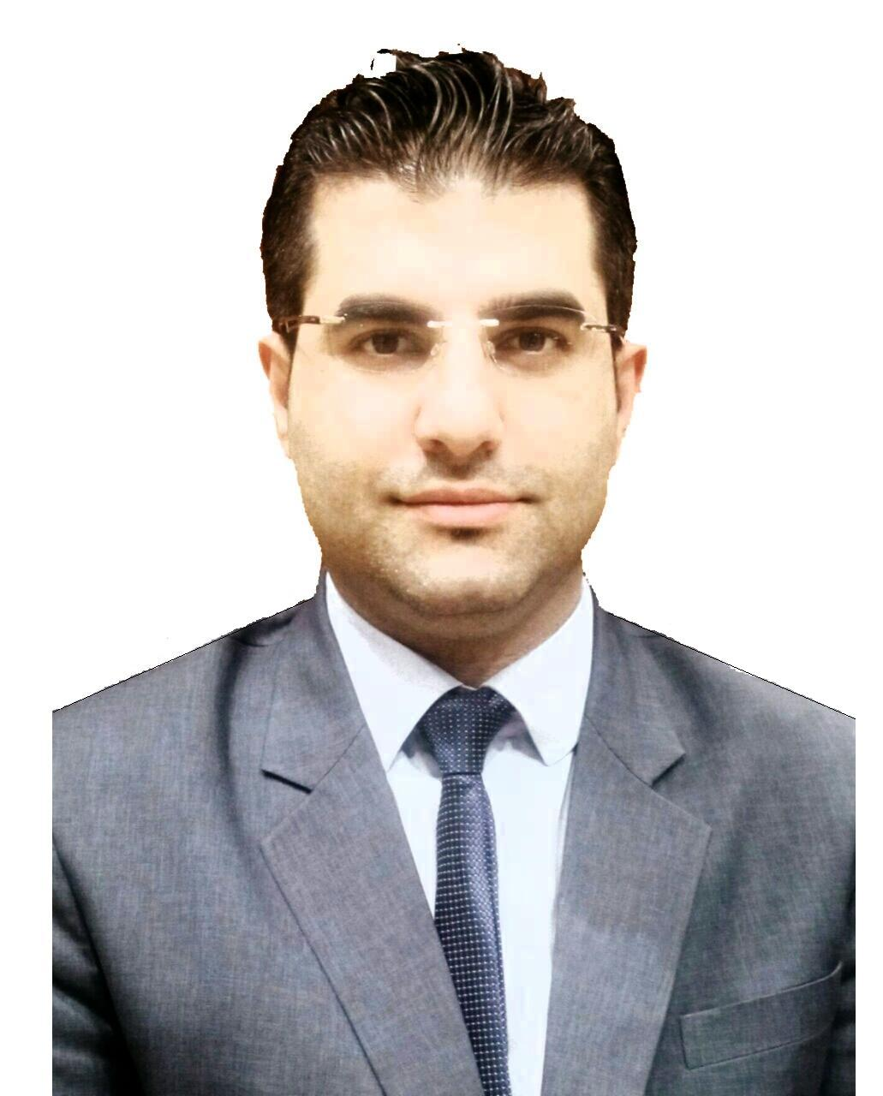

PERSONAL PROFILE:

I am an energetic, ambitious person who has developed a mature and responsible approach to any task that I undertake, or situation that I am presented with. With 11 years’ experience in management, I excel in working with others to achieve a certain objective on time that is of the highest quality. Being a natural problem solver, I enjoy overcoming challenges. I also have a genuine interest in Business Management- specifically, helping to improve the daily running of organizations to help them achieve success.

I am currently working as a trainee Robotic Process Automation Developer, and I am UiPath certified after passing my Professional Associate RPA Developer Exam. I am seeking career opportunities in this field to further develop my technical skills once my traineeship ends in November 2023.
EDUCATION HISTORY:

2022- Current RPA Developer (Trainee) undergoing Work Placement at Office of Public Works-Ireland
ABP School of Automation, Remote

2020-2022 Web Design – Advanced App & Web UI/UX Higher Diploma (HND) Level 6
Ballyfermot College of Further Education, Dublin

2019-2020 Business Administration QQI Level 5
Abbeyleix FETC., Abbeyleix, Co. Laois

2019-2019 Word QQI (L4) and Digital Media QQI (L3)
Abbeyleix FETC., Abbeyleix, Co. Laois

2011-2012 Managing and Marketing Course
Al Jaber Watches& Jewelry, Qatar-Al DOHA

2007-2009 Associate in Electrical Engineering, Diploma
Damascus University, Syria

2006-2007 Marketing Course
Balqes Institute Suwayda City, Syria
WORK EXPERIENCE:
Feb 2023- Current | Work Placement during my 12-month traineeship with ABP School of Automation. Developing new projects Using UiPath software for their client OPW (Office of Public Works) in Dublin, Ireland.
My role entails:

- Email Automation, Daily process to read email, download attached files, and insert to the App.
- Add and remove clients from ROS-OPW system.
- Add and remove clients’ accounts from ONE Accounting System.
- Copy sheets and data from Multiple files
- Extract data from pdf files and save it in excel file.
- Scrape data list and download files from Application.

Oct 2007- Sep 2018 | Show Room Manager (Retail Group of Company)  AL Jaber Watches & Jewelry Inc, Qatar-Doha
Job Description
- Managed sales budgets and set targets.
- Worked closely with the category managers and the marketing team to run promotions, organize events and optimize product offering.
- Ensured that the store operated in a professional manner and achieved all the key targets.
- Kept the elite standards of the products by promoting the image of the brands, and high standards of the merchandise.
- Attended to customer queries over the telephone and made a telemarketing strategy of selling by endorsing the products.

Achievements

- 2009- I was selected to be employee of the year.
- 2012- I was awarded a certificate in recognition of attaining in-depth knowledge
and expertise to achieve the status “Silver &Gold Level” in Frédérique Constant.
- 2013- I was awarded a certificate as the highest achiever of “Geovani Diamond Watches” and I felt an appreciation for my efforts in achieving the target.
- 2012-2018- I was managing all the operations of AL Jaber watches and jeweler’s section in Doha exhibition.
SKILLS:

- Robotic Process Automation Software (UiPath and Microsoft Power Automate)
- Design programmes (XD, Photoshop, Illustrator and InDesign).
- Coding Languages (HTML, CSS, PHP).
- UI/UX Skills
- Professional skills (Management, Leadership, Public Relations, Team Work).
- Communication skills (Great listening, Public Speaking, Networking).
- Customer service skills (Problem solving, Telephone Etiquette and Data Entry).
- Knowledgeable of general business IT (Microsoft office, Microsoft Teams)
- Languages- I am bilingual so able to speak both English and Arabic (mother tongue).
- Adaptable and creative, with the ability to work under pressure and take initiative.

REFERENCES:
Available on request.

